Bike Data

Jonathan Haynes

2023-03-14

# Business Task

Design marketing strategies aimed at converting casual riders into annual members.

# Data Sources Used

I used Cyclistic’s historical trip data to analyze and identify trends.

## Setting Up My Environment

Notes: setting up R environment by loading the ‘tidyverse’

## ── Attaching core tidyverse packages ──────────────────────── tidyverse 2.0.0 ──  
## ✔ dplyr 1.1.0 ✔ readr 2.1.4  
## ✔ forcats 1.0.0 ✔ stringr 1.5.0  
## ✔ ggplot2 3.4.1 ✔ tibble 3.2.0  
## ✔ lubridate 1.9.2 ✔ tidyr 1.3.0  
## ✔ purrr 1.0.1   
## ── Conflicts ────────────────────────────────────────── tidyverse_conflicts() ──  
## ✖ dplyr::filter() masks stats::filter()  
## ✖ dplyr::lag() masks stats::lag()  
## ℹ Use the ]8;;http://conflicted.r-lib.org/conflicted package]8;; to force all conflicts to become errors  
## Rows: 259716 Columns: 13  
## ── Column specification ────────────────────────────────────────────────────────  
## Delimiter: ","  
## chr (5): ride_id, rideable_type, start_station_name, end_station_name, memb...  
## dbl (6): start_station_id, end_station_id, start_lat, start_lng, end_lat, e...  
## dttm (2): started_at, ended_at  
##   
## ℹ Use `spec()` to retrieve the full column specification for this data.  
## ℹ Specify the column types or set `show_col_types = FALSE` to quiet this message.

## Summary of Analysis

After spending several days with this data. I can conclude that casual riders are the majority of Cyclistic customers but spend less time riding.

## Visualizations

Here we will go through several visualizations and key findings.

## Number of Rides Per Day

Here we plot average number of rides and usage daily. 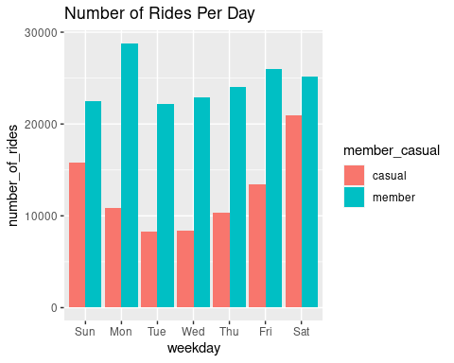

## Ride Length In Seconds

Here we plot average duration and weekdays. 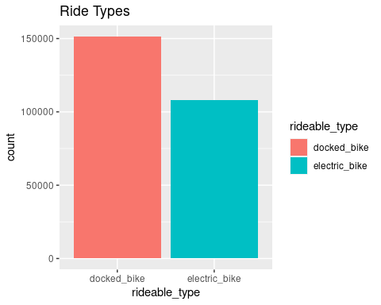

## Key Findings

1. How do annual members and casual riders use Cyclistic bikes differently?- Annual members duration of riding is consistent no matter the day. However casaulist ride more during the weekend.
2. How can Cyclistic use digital media to influence casual riders to become members? Cyclistic could offer promotions to casual members on docked bikes on the weekend contingent upon becoming an annual member.